Mira Vos
Business Plan

Brian Morman, Owner
Created on September 6, 2025

Executive Summary

Product
Mira Vos Drink Company manufactures high-quality exercise supplement powders and drinks with a real science-based focus on health and wellness. Our flagship drink “Mira Vos” is made with caffeine from Yerba Matte tea leaves from the heart of Argentina. Our products are made to support health-conscious people with the motivation to start new habits and the energy to maintain them.
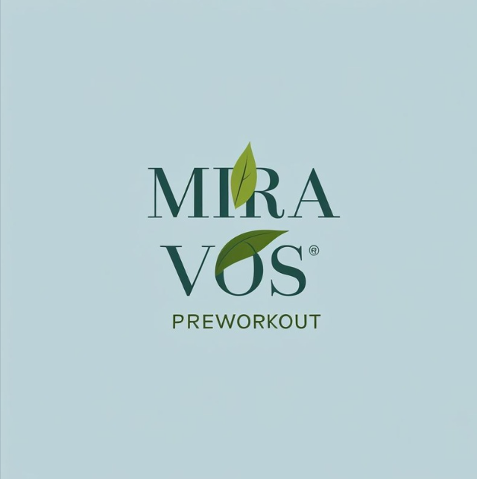

Customers
The target audience for Mira Vos are health enthusiasts who exercise regularly and pay attention to the food, drinks, and supplements they put in their body.

Future of the Company
Although the exercise supplement industry is highly competitive, we believe that there is a place for high-quality, attractive, science based, and natural supplements. Our goal is to build and market supplements and drinks that will encourage more people to get moving, make progress, and have the endurance to keep that good habit for life.

Company Description

Mission Statement
To get people moving and provide them the clean energy to become their best selves.

Principal Members
Brian Morman — owner, CEO
xxxxx — Marketing
xxxxx — Supply Chain and ops
xxxxx — web master and logistics handles shipping for web, mail, and special orders

Legal Structure
Mira Vos is a sole proprietorship. Initial sales will be made under the protection of an LLC.

Market Research

Industry
Mira Vos will be a part of the exercise supplement industry. The exercise supplement industry currently consists of 19.58b in revenue with a CAGR of 5.9 into 2030. 35.1% of that market is US-based with 88% in powder and xx% in ready-to-drink. The growing market is associated with a growing understanding of the importance of exercise for men and women. A trend towards simpler eating and increased focus on processed ingredients creates an opening for a pre-workout supplement drink with simple and natural ingredients.

Detailed Description of Customers

Name: Fit Fiona

Age: 30

Gender: Female or Male

Income Level: $60,000

Location: Urban area

Fitness Level: Intermediate

Goals: Wants to build lean muscle and improve workout performance.

Pain Points: Struggles with energy dips during workouts and is cautious about artificial ingredients in supplements.

Interests: Enjoys weightlifting, yoga, and healthy cooking. Follows fitness influencers on Instagram.

Preferred Channels: Engages with brands on Instagram and prefers online shopping for convenience.

Company Advantages
Mira Vos has the following advantages compared to competitors:
- Simple transparent ingredients
- Natural caffeine sourced from premium plants
- Sustainable faming processes

Regulations
Mira Vso must meet all federal and state regulations concerning exercise supplements. The supplements will be 3rd party tested and regulated under DSHEA. In Europe, exercise supplement drinks are regulated under the European Food Safety Authority.

Service Line

Product/Service
Mira Vos preworkout is made from natural ingredients utilizing caffeine from yerba matte leaf, niacin from natural yeast, plant based amino acids to promote creatine synthasis in the body, and citulline malate from watermelon. Our current list of flavors include:
- Watermelon lemonade
Packaging design is a key differentiator for products in this space. Mira Vos plans to utilize crowd sourced or AI design to experiment with the products look.

Pricing Structure
Mira Vos will offer its products for the following prices:
- Mira Vos Watermelon Lemonade Powder - $50

Product Lifecycle
Mira Vos is in the process of developing our recipe and flavor offerings.

Intellectual Property Rights
Mira Vos is pursuing a trademark name in the State of Missouri.

Research and Development
The company is planning to conduct the following research and development:
- Include a feedback mechanism on the website for ideas, suggestions, and improvements
- Provide comment cards for distribution at retail locations where trial sales are available.
- Review available market research to identify top flavors in this industry and reason(s) for their popularity
- Customer Research to better understand our target customers’ tastes and recipe preferences.

Marketing & Sales

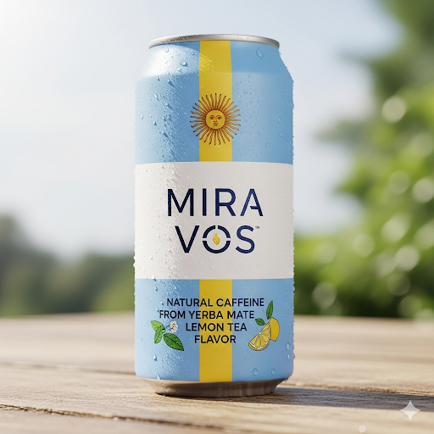

Growth Strategy
To grow the company, Mira Vos will do the following:
- Sell products at grocery stores, supplement stores, and gyms where available.
- As business grows, advertise in target markets, especially in advance of the holiday season.

Key Connections
- Flavor Mixer – Beck flavors
- Co-mixer monon pax
- Packaging firm TBD

Communicate with the Customer
Mira Vos will communicate with its customers by:
- Providing an email newsletter with company news, product information, and pop-up locations and schedules.
- Using targeted Google, Instagram, and TikTok advertisements.
- Providing contact information on the company website.
- Reach out to target podcasts for growth in brand recognition.

How to Sell
THIS SECTION IS IN WORK

Next Steps
- Finalize product recipe and flavor offerings -
- Register LLC and product trademarks
- Fund raise for initial SKU inventory
- Research what it takes to get in the door at stores
- Obtain 3rd party testing along with any approvals possible - https://www.eurofinsus.com/food-testing/services/testing-services/nutrition-analysis/
NSF testing

